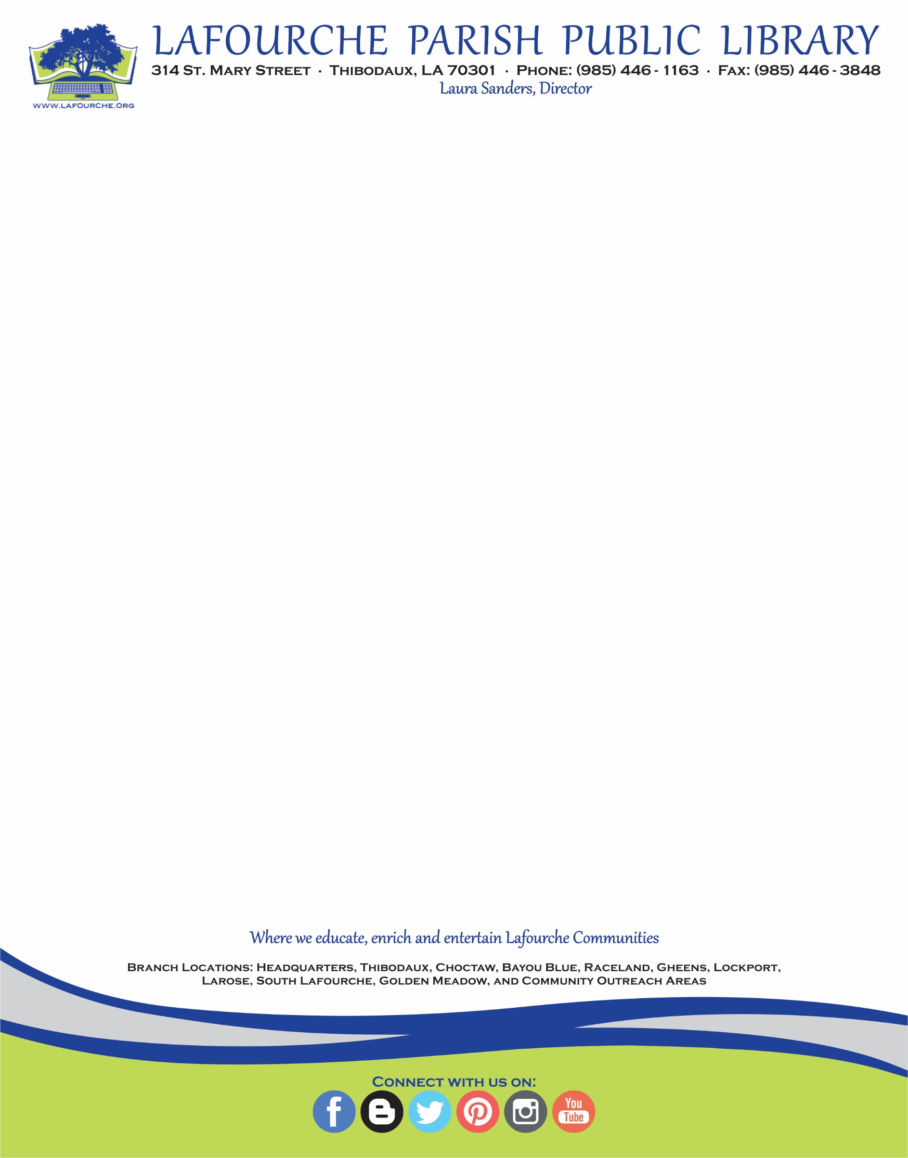

November 10, 2017

Library Board of Control

All Branches

News Media

Ladies and Gentlemen:

This is to advise that the regular meeting of the ***Library Board of Control*** meeting scheduled for ***Tuesday, November 14, 2017*** has been ***canceled.***